EMPLOYMENT APPLICATION REVIEW SYSTEM (EARS)

Detailed Design Document

Version 1.0 approved

Prepared by:
Chisom Ugochukwu
Yinka Akingbaso

Algoma University
July 29, 2026

1. UML Class Diagram
The system is modelled as five cooperating classes (Figure 1). Each class encapsulates its own state and behavior, and relationships are expressed with explicit multiplicities.
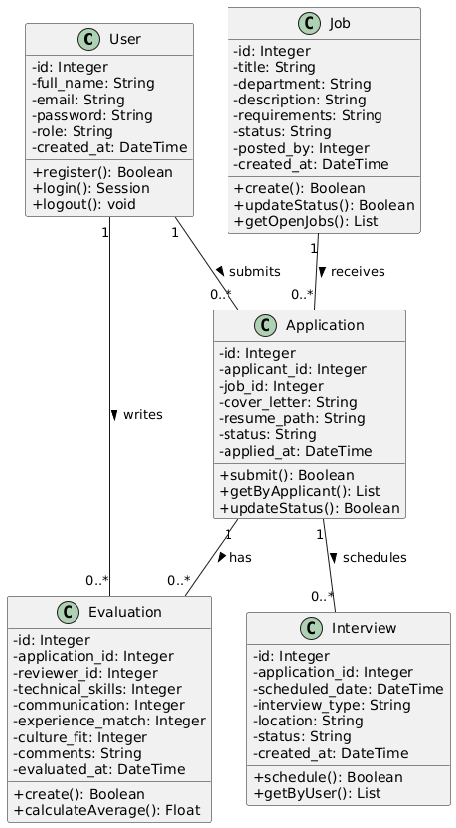
Figure 1: UML class diagram — entities, attributes, methods, and relationships
Class | Responsibility | Key Methods
User | Identity, credentials (hashed), and role (applicant, reviewer, admin) | register(), login(), logout()
Job | Job postings with lifecycle status (open, closed) | create(), updateStatus(), getOpenJobs()
Application | Cover letter, resume, and status for one applicant–job pairing | submit(), getByApplicant(), updateStatus()
Evaluation | Four criterion scores (1–5) plus comments for an application | create(), calculateAverage(), getByApplication()
Interview | Scheduled date, type, location, and status for an application | schedule(), getByUser()

Relationship | Multiplicity
User submits Application | 1 to 0..*
Job receives Application | 1 to 0..*
User writes Evaluation | 1 to 0..*
Application has Evaluation | 1 to 0..*
Application schedules Interview | 1 to 0..*

2. Sequence Diagram: Application Submission
Figure 2 traces the submission of an application across the browser, authentication middleware, application controller, and database — including the duplicate-application exception path.
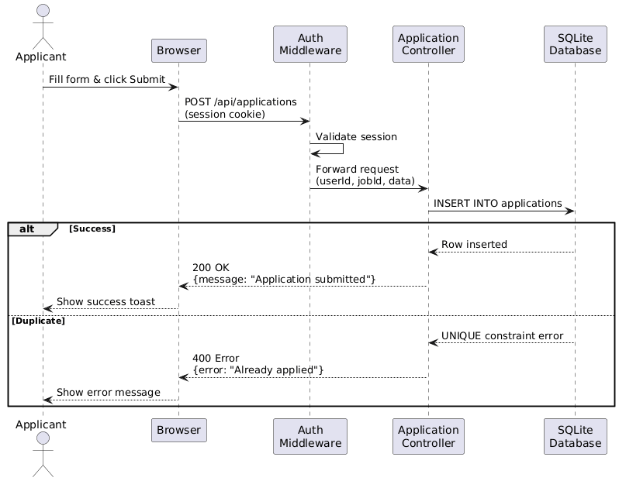
Figure 2: Sequence diagram — application submission with success and duplicate branches
Step | Interaction | Message
1 | Applicant → Browser | Fill the application form and click Submit
2 | Browser → Auth Middleware | POST /api/applications (with session cookie)
3 | Auth Middleware → Controller | Validate session; extract userId
4 | Controller → Database | INSERT INTO applications (applicant_id, job_id, cover_letter, resume_path)
5 | Database → Controller | Return success, or UNIQUE constraint error on duplicate
6 | Controller → Browser | JSON {message: "Application submitted"} or {error: "Already applied"}
7 | Browser → Applicant | Display success toast or error message

3. Activity Diagram: Application Review Workflow
The reviewer workflow is a sequence of decisions, each with a defined system response:
- The reviewer logs in and opens the applications dashboard.
- The reviewer selects an application and decides whether to evaluate the candidate.
- If yes: open the evaluation form, enter the four scores (1–5 each), and the system calculates the average and saves the evaluation.
- The reviewer then decides whether to update the application status; if yes, they select the new status and save.
- At any decision point the reviewer may schedule an interview by entering the date, type, and location; the system saves the interview and notifies the applicant.
- Each branch terminates cleanly — no workflow path leaves the application in an undefined state.

4. State Diagram: Application Lifecycle
An application moves through five states. Every transition is triggered by an explicit reviewer action, and every state is reachable from the applicant-facing status badge.
From State | Trigger | To State
Pending | Reviewer opens the application | Under Review
Under Review | Evaluation completed | Interview
Interview | Interview passed | Accepted
Interview | Interview failed | Rejected
Pending | Immediate rejection | Rejected
Under Review | Does not meet criteria | Rejected

5. Data Flow Diagram (Level 1)
The Level-1 DFD identifies three external entities, five processes, and five data stores.
External Entities | Processes | Data Stores
Applicant | P1 — Authenticate | D1 — Users
Reviewer | P2 — Manage Jobs | D2 — Jobs
Administrator | P3 — Submit Application | D3 — Applications
 | P4 — Review Applications | D4 — Evaluations
 | P5 — Schedule Interviews | D5 — Interviews

Entity | Process | Data Flow
Applicant | P1 — Authenticate | Credentials verified against D1 (Users)
Applicant | P3 — Submit Application | Writes D3 (Applications); reads D2 (Jobs)
Reviewer | P1 — Authenticate | Credentials verified against D1 (Users)
Reviewer | P4 — Review Applications | Reads D3 (Applications); writes D4 (Evaluations)
Reviewer | P5 — Schedule Interviews | Writes D5 (Interviews); reads D3 (Applications)
Administrator | P1 — Authenticate | Credentials verified against D1 (Users)
Administrator | P2 — Manage Jobs | Writes D2 (Jobs)

